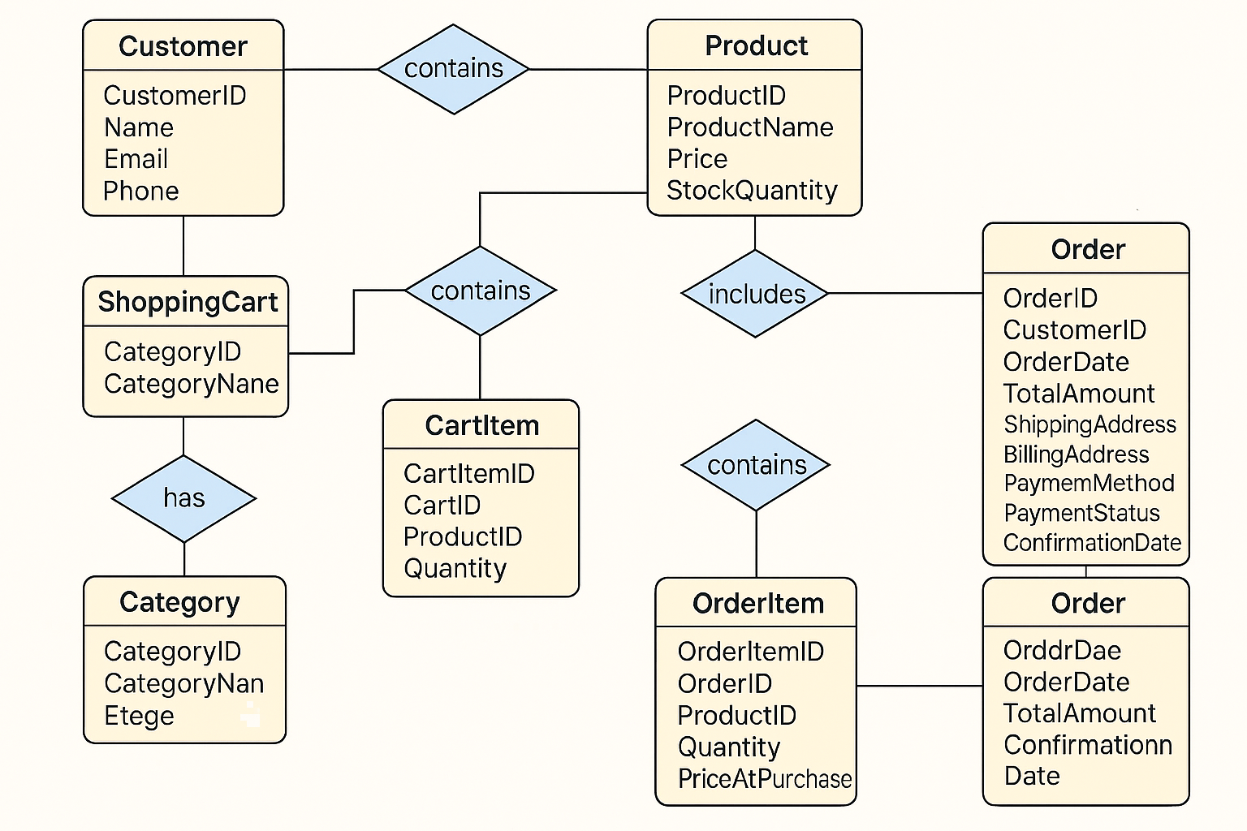

Thanks Djuma! Based on your ER diagram and use case, here's a suggested **folder structure for the cartapp Django app**, including models, serializers, services, views, tasks, and admin configuration.

**📁 cartapp/ Structure**

cartapp/

├── __init__.py

├── admin.py

├── apps.py

├── models/

│ ├── __init__.py

│ ├── customer.py

│ ├── category.py

│ ├── product.py

│ ├── cart.py

│ ├── cart_item.py

│ ├── order.py

│ └── order_item.py

├── serializers/

│ ├── __init__.py

│ ├── customer_serializer.py

│ ├── category_serializer.py

│ ├── product_serializer.py

│ ├── cart_serializer.py

│ ├── cart_item_serializer.py

│ ├── order_serializer.py

│ └── order_item_serializer.py

├── services/

│ ├── __init__.py

│ ├── cart_service.py

│ ├── order_service.py

│ └── checkout_service.py

├── views/

│ ├── __init__.py

│ ├── cart_views.py

│ ├── product_views.py

│ ├── order_views.py

│ └── category_views.py

├── tasks/

│ ├── __init__.py

│ └── order_tasks.py

├── urls.py

└── tests/

├── __init__.py

├── test_cart.py

├── test_order.py

└── test_checkout.py

**🧠 Explanation of Each Folder**

* **models/**: Contains modular model files for each entity in your ER diagram (Customer, Product, Cart, etc.).
* **serializers/**: DRF serializers for converting model instances to JSON and validating incoming data.
* **services/**: Business logic like adding items to cart, calculating totals, processing checkout.
* **views/**: API views or class-based views for handling requests (e.g., browsing products, viewing cart).
* **tasks/**: Background tasks (e.g., sending confirmation emails, updating stock) using Celery or Django Q.
* **admin.py**: Register models for Django admin interface.
* **urls.py**: Route endpoints for cart, products, orders, etc.
* **tests/**: Unit and integration tests for cart and order functionality.

To integrate **Commerce & Inventory** modules (CatalogApp, InventoryApp) with the rest of your system, follow this modular strategy based on the architecture shown in your image:

**🔧 1. Infrastructure & Control Integration**

Apps: FarmApp, HousesApp, FlocksApp, SectorApp, AccountApp

* **Purpose**: Ensure that inventory reflects real-time infrastructure changes.
* **Integration Ideas**:
  + When a new flock is added in FlocksApp, update feed and vaccine requirements in InventoryApp.
  + Link SectorApp to define inventory zones or warehouses.
  + Use AccountApp to manage user permissions for accessing inventory and commerce data.

**🐔 2. Operations Integration**

Apps: BirdApp, FeedingApp, WaterApp, CleaningApp, HealthVaccinationApp

* **Purpose**: Track inventory consumption during daily operations.
* **Integration Ideas**:
  + FeedingApp deducts feed quantities from InventoryApp.
  + CleaningApp uses cleaning products from CatalogApp and updates stock.
  + HealthVaccinationApp logs vaccine usage and triggers reorder alerts via InventoryApp.

**📊 3. Analytics & Reporting Integration**

Apps: DashboardApp, ReportApp

* **Purpose**: Provide visibility into stock levels, product movement, and commerce metrics.
* **Integration Ideas**:
  + DashboardApp shows real-time inventory status and sales trends.
  + ReportApp generates periodic reports on stock usage, supplier performance, and product turnover.

**⚙️ 4. Admin & Configuration Integration**

Apps: SettingsApp, NotificationApp

* **Purpose**: Configure system behavior and alert users.
* **Integration Ideas**:
  + SettingsApp defines reorder thresholds, preferred suppliers, and product categories.
  + NotificationApp sends alerts for low stock, new orders, or supplier delays.

**🔗 Integration Strategy Summary**

| **Module** | **Integration Target** | **Purpose** |
| --- | --- | --- |
| CatalogApp | Operations | Track product usage |
| InventoryApp | Infrastructure | Reflect physical changes |
| InventoryApp | Analytics | Report stock levels |
| CatalogApp | Admin | Configure product settings |
| InventoryApp | Notification | Alert on stock events |

Would you like a visual integration map or code scaffolding to implement these connections (e.g., signals, services, or API endpoints)?

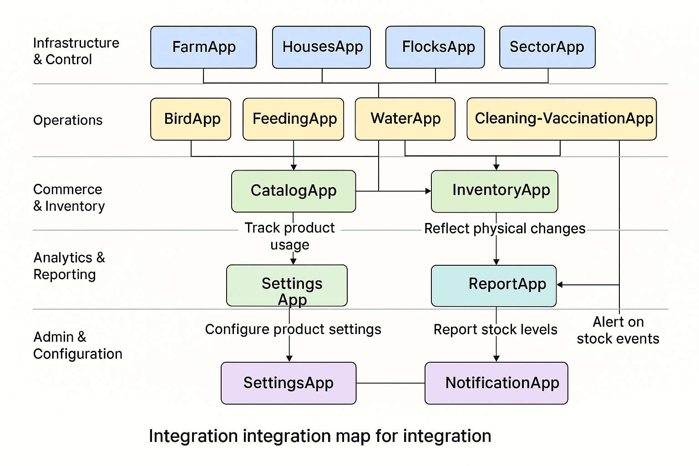

**Visual Integration Map**

Here is the **visual integration map** showing how CatalogApp and InventoryApp connect with other modules like FarmApp, BirdApp, DashboardApp, and NotificationApp:

!Visual Integration Map

**🧱 Code Scaffolding Examples**

Here’s how you can structure your **Django services** and **API endpoints** to enable integration:

**📦 catalogapp/services/product_service.py**

**Python**

class ProductService:

@staticmethod

def get_product_by_id(product_id):

from catalogapp.models import Product

return Product.objects.filter(id=product_id).first()

**📦 inventoryapp/services/stock_service.py**

**Python**

class StockService:

@staticmethod

def check_stock(product_id, required_quantity):

from inventoryapp.models import InventoryItem

item = InventoryItem.objects.filter(product_id=product_id).first()

return item and item.quantity >= required_quantity

@staticmethod

def deduct_stock(product_id, quantity):

item = InventoryItem.objects.filter(product_id=product_id).first()

if item and item.quantity >= quantity:

item.quantity -= quantity

item.save()

return True

return False

Show more lines

**📦 notificationapp/services/notification_service.py**

**Python**

class NotificationService:

@staticmethod

def send_stock_alert(product_name, current_quantity):

from notificationapp.models import Notification

Notification.objects.create(

title="Low Stock Alert",

message=f"Stock for {product_name} is low: {current_quantity} units remaining."

)

**🌐 API Endpoint Example**

**📁 inventoryapp/views/stock_views.py**

**Python**

from rest_framework.decorators import api_view

from rest_framework.response import Response

from inventoryapp.services.stock_service import StockService

from catalogapp.services.product_service import ProductService

from notificationapp.services.notification_service import NotificationService

@api_view(['POST'])

def check_and_deduct_stock(request):

product_id = request.data.get('product_id')

quantity = int(request.data.get('quantity', 0))

product = ProductService.get_product_by_id(product_id)

if not product:

return Response({'error': 'Product not found'}, status=404)

if StockService.check_stock(product_id, quantity):

StockService.deduct_stock(product_id, quantity)

return Response({'message': 'Stock deducted successfully'})

else:

NotificationService.send_stock_alert(product.name, 0)

return Response({'error': 'Insufficient stock'}, status=400)

Show more lines

⚠️ Note: You’ll need to install Django REST Framework to use api_view and Response.

**Shell**

pip install djangorestframework

Would you like me to generate a full working Django module with these services and endpoints scaffolded into files?

To integrate the **Operations module** (which includes BirdApp, FeedingApp, WaterApp, CleaningApp, and Health-VaccinationApp) with other modules in your system, here's a structured approach based on the architecture shown in your image:

**🔗 Integration Strategy by Module**

**1. With Infrastructure & Control**

Apps: FarmApp, HousesApp, FlocksApp, SectorApp, AccountApp

* **Purpose**: Ensure operational activities are aligned with physical infrastructure.
* **Integration Ideas**:
  + Link BirdApp and FlocksApp to track bird population per house or sector.
  + Use FarmApp and SectorApp to define operational zones for feeding, cleaning, and watering.
  + AccountApp manages user roles for accessing and executing operational tasks.

**2. With Commerce & Inventory**

Apps: CatalogApp, InventoryApp

* **Purpose**: Track usage of products and supplies during operations.
* **Integration Ideas**:
  + FeedingApp deducts feed from InventoryApp.
  + CleaningApp uses cleaning products listed in CatalogApp.
  + Health-VaccinationApp logs vaccine usage and updates inventory.

**3. With Analytics & Reporting**

Apps: DashboardApp, ReportApp

* **Purpose**: Monitor operational performance and resource consumption.
* **Integration Ideas**:
  + DashboardApp visualizes daily feed usage, water consumption, and health interventions.
  + ReportApp generates summaries of operational activities per flock or house.

**4. With Admin & Configuration**

Apps: SettingsApp, NotificationApp

* **Purpose**: Configure operational parameters and alert users.
* **Integration Ideas**:
  + SettingsApp defines feeding schedules, cleaning intervals, and vaccination plans.
  + NotificationApp sends alerts for missed operations, low inventory, or health issues.

**🧱 Example Integration Flow**

**Scenario**: A flock in BirdApp requires feeding.

1. BirdApp checks flock size and feed requirements.
2. FeedingApp calculates required feed and calls InventoryApp to check stock.
3. If stock is sufficient, feed is deducted and logged.
4. DashboardApp updates feed usage metrics.
5. If stock is low, NotificationApp sends an alert.

Would you like a visual flow diagram or code scaffolding for this integration scenario?

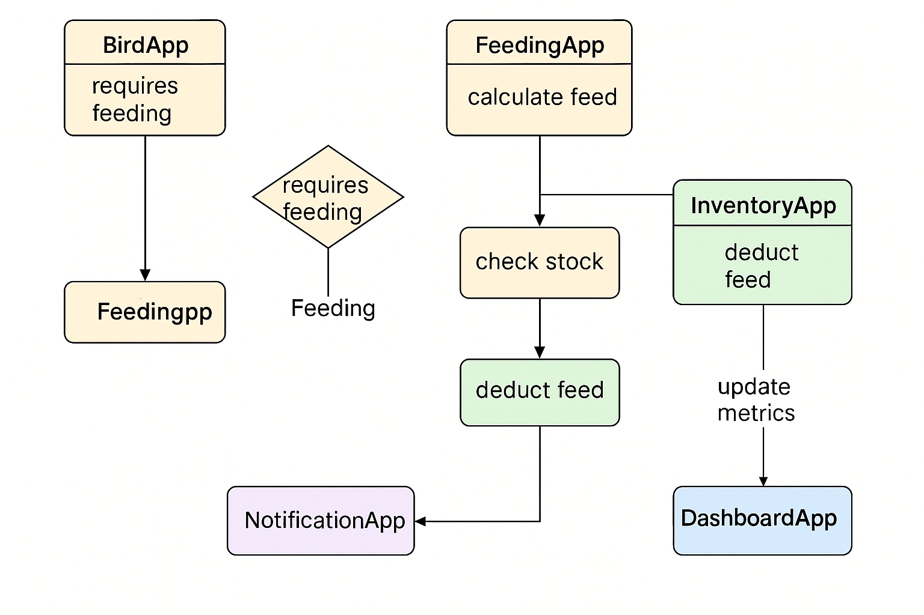

**Visual Flow Diagram for Operations Integration**

Here is the **visual flow diagram** showing how the **Operations module** (BirdApp, FeedingApp, WaterApp, CleaningApp, HealthVaccinationApp) integrates with:

* **Infrastructure & Control**
* **Inventory**
* **Analytics & Reporting**
* **Admin & Notification**

!Operations Integration Flow

**🧱 Code Scaffolding for Integration**

Here’s a modular example using Django services and signals:

**📦 feeding_service.py (Operations → Inventory, Analytics, Notification)**

**Python**

class FeedingService:

@staticmethod

def feed_flock(flock_id, feed_type, quantity):

from inventoryapp.services.stock_service import StockService

from notificationapp.services.notification_service import NotificationService

from analyticsapp.services.metrics_service import MetricsService

if not StockService.check_stock(feed_type, quantity):

NotificationService.send_stock_alert(feed_type, quantity)

return False

StockService.deduct_stock(feed_type, quantity)

from operations.models import FeedingLog

FeedingLog.objects.create(flock_id=flock_id, feed_type=feed_type, quantity=quantity)

MetricsService.log_feed_usage(flock_id, quantity)

return True

Show more lines

**📦 notification_service.py**

**Python**

class NotificationService:

@staticmethod

def send_stock_alert(product_name, current_quantity):

from notificationapp.models import Notification

Notification.objects.create(

title="Low Stock Alert",

message=f"Stock for {product_name} is low: {current_quantity} units remaining."

)

@staticmethod

def send_operation_alert(operation_type, message):

Notification.objects.create(

title=f"{operation_type} Alert",

message=message

)

Show more lines

**📦 signals.py (Trigger Notifications on Feeding Events)**

**Python**

from django.db.models.signals import post_save

from django.dispatch import receiver

from operations.models import FeedingLog

from notificationapp.services.notification_service import NotificationService

@receiver(post_save, sender=FeedingLog)

def notify_feeding_event(sender, instance, created, **kwargs):

if created:

NotificationService.send_operation_alert(

"Feeding",

f"Flock {instance.flock_id} was fed {instance.quantity} units of {instance.feed_type}."

)

**🔔 Notification Triggers in Operations**

Here are common triggers for sending notifications:

| **Operation Module** | **Trigger Event** | **Notification Type** |
| --- | --- | --- |
| FeedingApp | Low feed stock | Stock Alert |
| CleaningApp | Missed cleaning schedule | Operation Alert |
| HealthVaccinationApp | Upcoming or overdue vaccination | Reminder / Alert |
| BirdApp | Mortality or abnormal behavior logged | Health Alert |
| WaterApp | Water supply below threshold | Resource Alert |

Would you like me to scaffold these into actual Django files or generate a test suite for these integrations?

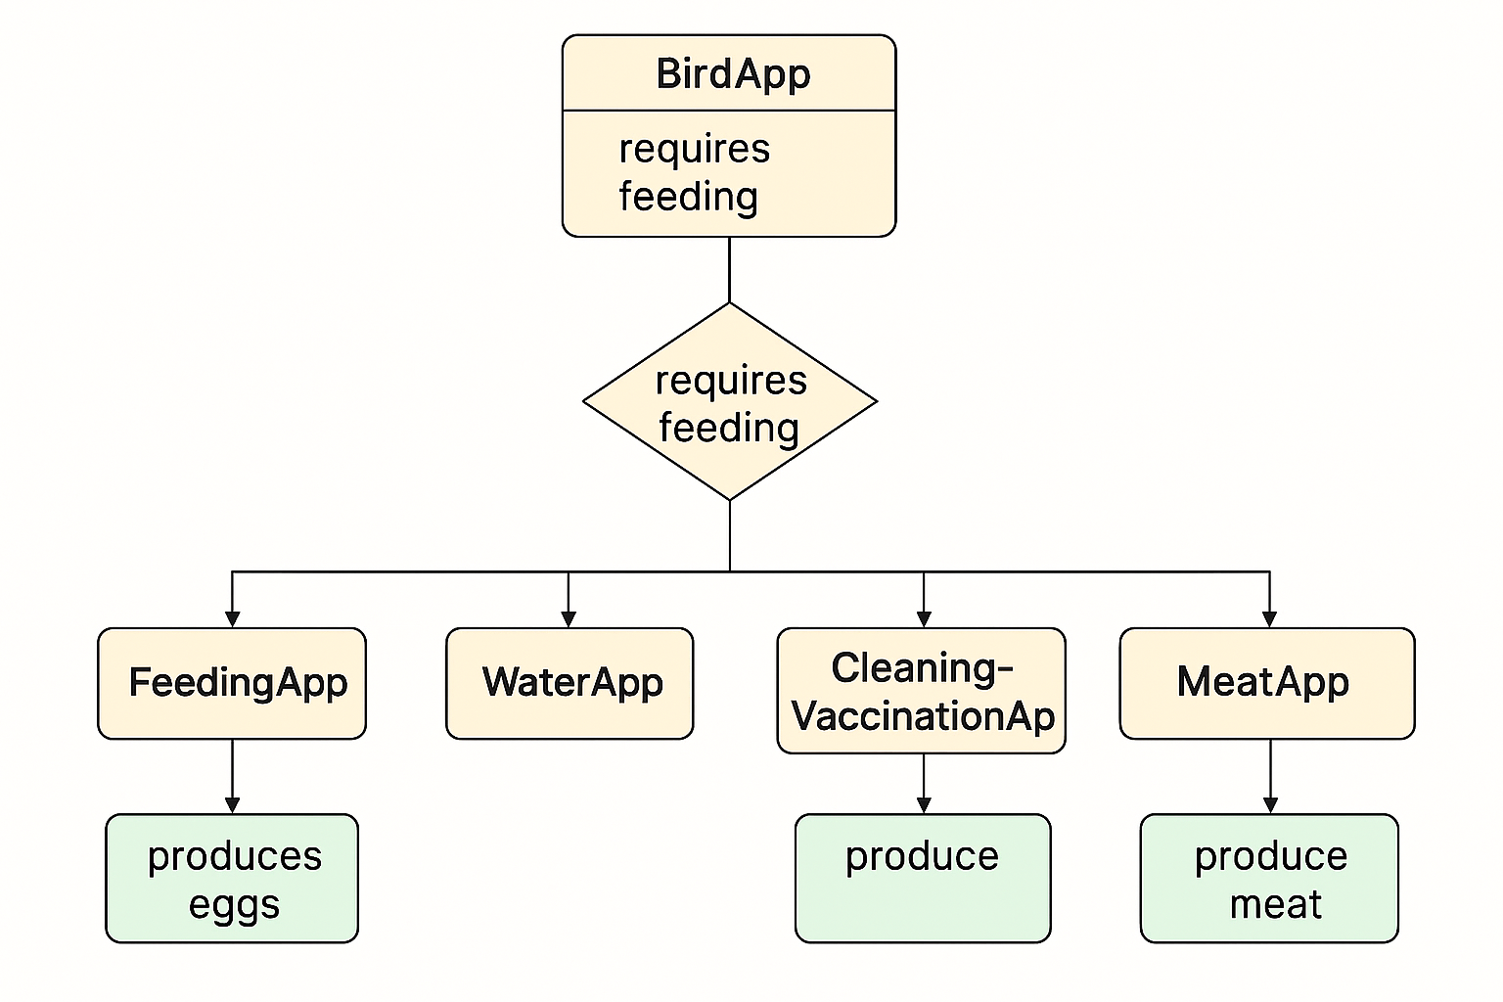

Would you like me to generate the actual models.py files for each entity based on your ER diagram?

Got it — thanks for the reminder! ✅

Since **Product** and **Category** are in cartapp under the **Commerce & Inventory** module, here's how you can integrate BirdApp (from the **Operations** module) with them and other modules:

**🔗 Integration Map for BirdApp**

| **BirdApp Feature** | **Integrated Module** | **Purpose** |
| --- | --- | --- |
| **Feeding** | InventoryApp, cartapp.Product | Deduct feed stock, validate product type |
| **Watering** | SettingsApp, DashboardApp | Configure schedules, monitor usage |
| **Vaccination** | InventoryApp, cartapp.Product, HealthVaccinationApp | Track vaccine stock, log health events |
| **Health Check** | HealthVaccinationApp, ReportApp | Record health status, generate reports |
| **Egg & Meat Production** | cartapp.Product, InventoryApp, DashboardApp | Register products, update stock, visualize output |

**🧱 Example Integration Code**

**📁 birdapp/services/production_service.py**

class ProductionService:

@staticmethod

def register_production(flock_id, product_slug, quantity):

from cartapp.models import Product

from inventoryapp.models import InventoryItem

from dashboardapp.services.metrics_service import MetricsService

product = Product.objects.filter(slug=product_slug).first()

if not product:

raise ValueError("Product not found")

item, _ = InventoryItem.objects.get_or_create(product=product)

item.quantity += quantity

item.save()

MetricsService.log_production(flock_id, product.name, quantity)

**📁 birdapp/services/feeding_service.py**

class FeedingService:

@staticmethod

def feed_flock(flock_id, product_slug, quantity):

from cartapp.models import Product

from inventoryapp.services.stock_service import StockService

from notificationapp.services.notification_service import NotificationService

product = Product.objects.filter(slug=product_slug).first()

if not product:

NotificationService.send_operation_alert("Feeding", "Feed product not found")

return False

if not StockService.check_stock(product.id, quantity):

NotificationService.send_stock_alert(product.name, quantity)

return False

StockService.deduct_stock(product.id, quantity)

return True

**🔔 Notification Triggers in BirdApp**

| **Trigger** | **Notification** |
| --- | --- |
| Feed product not found | "Feeding Alert: Product not found" |
| Low feed stock | "Low Stock Alert: Feed" |
| Missed vaccination | "Vaccination Alert: Due" |
| Health anomaly | "Health Alert: Flock {id}" |
| Drop in egg/meat production | "Production Alert: Below expected" |

Would you like me to scaffold these into Django files or generate a flowchart showing how these services interact across modules?

